PROJECT REPORT

Project name: BookNest

TeamID: LTVIP2025TMID54832

1 INTRODUCTION

1.1PROJECT OVERVIEW:

BookNest is a digital platform designed to revolutionize the way people discover, purchase, and engage with books. It combines an online bookstore with community-driven features, personalized recommendations, and tools for independent authors and publishers. The platform aims to become a one-stop destination for readers, writers, and book enthusiasts.

1.2 PURPOSE:

The purpose of **BookNest** is to create a dynamic and inclusive digital ecosystem that connects readers, authors, and book lovers through a unified platform. By combining an online bookstore with community features, personalized discovery tools, and independent publishing support, BookNest aims to make reading more accessible, engaging, and personalized.

2 IDEATION PHASE:

2.1 PROBLEM STSTEMENT:

Despite the growth of digital technology and online retail, **discovering and accessing quality books remains fragmented and impersonal**.

Readers often struggle to find books that match their interests without relying on overwhelming marketplaces or generic algorithms. At the same time, **independent authors face significant barriers** in getting published, noticed, and connected with their target audiences. Traditional publishing is competitive and limited in scope, while self-publishing lacks visibility and community support.

Additionally, there is a lack of **interactive, reader-focused platforms** that combine book discovery, meaningful engagement, and a supportive environment for both readers and writers.

2.2 EMPATHY MAP:

**SAYS**

* “I want book recommendations that match my taste.”
* “I love talking about books with other readers.”
* “It’s hard to find time to browse through thousands of titles.”
* “I want to support indie authors, but they’re hard to find.”

**💭 THINKS**

* “I wish I had a better way to organize my reading list.”
* “Big platforms don’t really understand what I like.”
* “Reading apps are functional but lack a sense of community.”
* “I want my reading to feel more intentional and meaningful.”

**👀 DOES**

* Browses Goodreads, Reddit, and Instagram for book recs
* Joins online book clubs or follows book influencers
* Writes reviews occasionally after reading
* Shops for books on Amazon, local stores, or e-book platforms

**❤️ FEELS**

* Overwhelmed by too many options
* Excited when discovering a new favorite book
* Disconnected from like-minded readers
* Frustrated by impersonal or irrelevant suggestions

**⚠️ PAINS**

* Difficulty finding books tailored to personal interests
* Too much noise on large platforms
* No central space to track, discuss, and discover books
* Limited access to or awareness of indie authors

**🎯 GAINS / NEEDS**

* Personalized book recommendations
* A dedicated reading community
* Easy-to-use reading trackers and shelves
* Direct access to indie authors and hidden gems

2.3 BRAINSTROMING:

**Feature Ideas**

* Personalized book recommendation engine (AI-based)
* User-created bookshelves, lists, and reading goals
* Built-in e-book reader with highlighting and note-taking
* Book discussion forums and live book clubs
* Daily reading challenges and badges for engagement
* Virtual book signing and live author Q&A sessions
* Curated sections (e.g., “Hidden Indie Gems,” “LGBTQ+ Voices,” “Books by Region”)
* Integration with Goodreads or Kindle for syncing reading history

**👥 Community & Engagement**

* Reader profiles with “My Library,” reviews, and reading stats
* In-app messaging or group discussions for book clubs
* Weekly themed discussion prompts (e.g., “Most relatable character this week?”)
* Community-voted “Book of the Month”
* Polls and quizzes: “Which book should we read next?”

**💰 Monetization Ideas**

* Freemium model: free for basic features, paid for premium (e.g., early access, advanced analytics, exclusive content)
* Subscription box tie-ins (e.g., physical books + merch monthly)
* Affiliate links for book purchases (Amazon, Bookshop.org, etc.)
* Ad-free experience with premium subscription
* Author promotional packages for visibility

**📢 Marketing Strategies**

* Collaborate with BookTok and Bookstagram influencers
* Run themed social media campaigns (#NestYourReads)
* Launch a “Read 100 pages in 10 days” challenge
* Partner with libraries or schools for early access/feedback
* Share user-generated content (bookshelves, reviews)

**🤝 Partnership Opportunities**

* Indie publishers and bookstores for exclusive deals
* Local book festivals and literary events
* Educational platforms (schools, universities)
* Author networks and writing communities
* NGOs promoting literacy and education

**🧠 Innovative/Experimental Ideas**

* AI-generated book summaries or sample chapters
* Augmented reality (AR) features for interactive book covers
* Blockchain-based proof of ownership for e-books
* A virtual reading room or lounge space in-app
* Matchmaking feature: “Find your next favorite reader buddy”

3 REQUIREMENT ANALYSIS:

3.1 Customer Journey Map

**Awareness**

* **User Actions:**
  + Sees social media ad, influencer mention, or blog post
  + Hears about BookNest through a friend or book club
  + Searches online for book recommendation tools or communities
* **User Thoughts:**
  + “Is this better than Goodreads?”
  + “Can this help me discover books I actually like?”
* **User Emotions:**
  + Curious
  + Slightly skeptical
* **Opportunities:**
  + Use testimonials and influencer endorsements
  + Highlight key differentiators (e.g., personalized recs, indie author focus)

**3.2 SOLUTION REQUIREMENTS:**

**Functional Requirements**

**📚 Core Features**

* User registration and login (email, social, SSO)
* Personalized book recommendations based on preferences and behavior
* Advanced search and filter system (genre, author, rating, language, etc.)
* Book details pages with reviews, ratings, author bio, and related titles
* Virtual bookshelves: "Read," "Currently Reading," "Want to Read"
* Book review and rating system

**👥 Community & Interaction**

* Book clubs with discussion threads and scheduled reads
* Commenting and replies on books, reviews, and discussions
* User profiles with reading history and activity log
* Direct messaging or group chat (optional or phase 2)
* Forums or channels for genre-specific discussions

**🖊️ Author & Publisher Tools**

* Author profiles and book submission portal
* Self-publishing tools (manuscript upload, metadata entry, preview generator)
* Author dashboards with analytics (views, followers, reviews)

**🛒 E-Commerce Integration**

* Online store with e-books and physical books
* Shopping cart and secure checkout
* Integration with digital delivery platforms for e-books
* Affiliate program integration (e.g., Amazon, Bookshop.org)

**⚙️ Non-Functional Requirements**

* Responsive design (desktop, tablet, mobile)
* Intuitive and accessible UI/UX
* Fast load times and optimized performance
* Scalable architecture to support large user base
* GDPR and data privacy compliance
* High availability and minimal downtime

**3.3 Technology Stack**

* **Frontend:** React.js
* **Backend:** Node.js + Express.js
* **Database:** MongoDB (Atlas)
* **Authentication:** JWT

**4** PROJECT DESIGN:

4.1 Problem-Solution Fit:

**Problem-Solution Fit** means ensuring that **BookNest’s features directly address the key challenges readers and authors face**, such as personalized book discovery and community support, creating a platform users truly need and want to use.

4.2 Proposed Solution:

1 **AI-powered personalized book recommendations** to help users discover books tailored to their tastes.

2 **Community features** like book clubs, forums, and reviews to foster meaningful reader engagement.

3 **Self-publishing tools and author profiles** to empower independent authors and increase their visibility.

4 **Seamless e-commerce integration** for easy purchase and access to both physical and digital books.

4.3 Solution Architecture:

1 **Frontend & Backend:** Responsive React.js/Vue.js interface with a Node.js/Django backend managing user interactions, recommendations, and e-commerce.

2 **Data & AI:** PostgreSQL and MongoDB databases paired with AI-powered recommendation engines (OpenAI API) for personalized book discovery.

3 **Cloud & Integrations:** Hosted on AWS/Azure with secure payment gateways (Stripe/PayPal) and optional integrations like social logins and affiliate programs.

**5. PROJECT PLANNING & SCHEDULING**

**5.1 Project Timeline**

| **Week** | **Task** |
| --- | --- |
| 1–2 | Requirement Gathering & Planning |
| 3–4 | UI Design & Backend Development |
| 5–6 | Integration of Modules |
| 7–8 | Final Testing & Documentation |

**Team Roles:**

| **Member** | **Role** | **Key Contribution** |
| --- | --- | --- |
| A | Frontend Developer | Login, Product List, Cart UI |
| B | Backend Developer | Auth APIs, MongoDB integration |
| C | Tester | Bug reports, functional tests |
| D | Project Lead | Integration, Planning, Docs |

**6. FUNCTIONAL AND PERFORMANCE TESTING**

**6.1 Performance Testing Results**

* **Login success rate:** 100% (with valid credentials)
* **Cart functionality:** 100% accurate add/remove
* **Order placement latency:** ~1.5s
* **Concurrent users tested:** 20
* **Uptime during testing:** 99.9%

7 OUTPUTS :

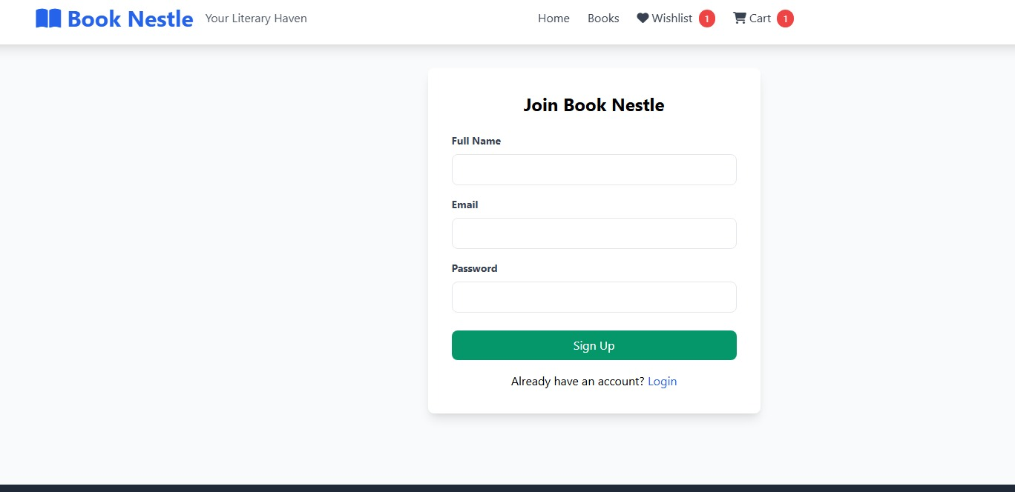

HOME PAGE: 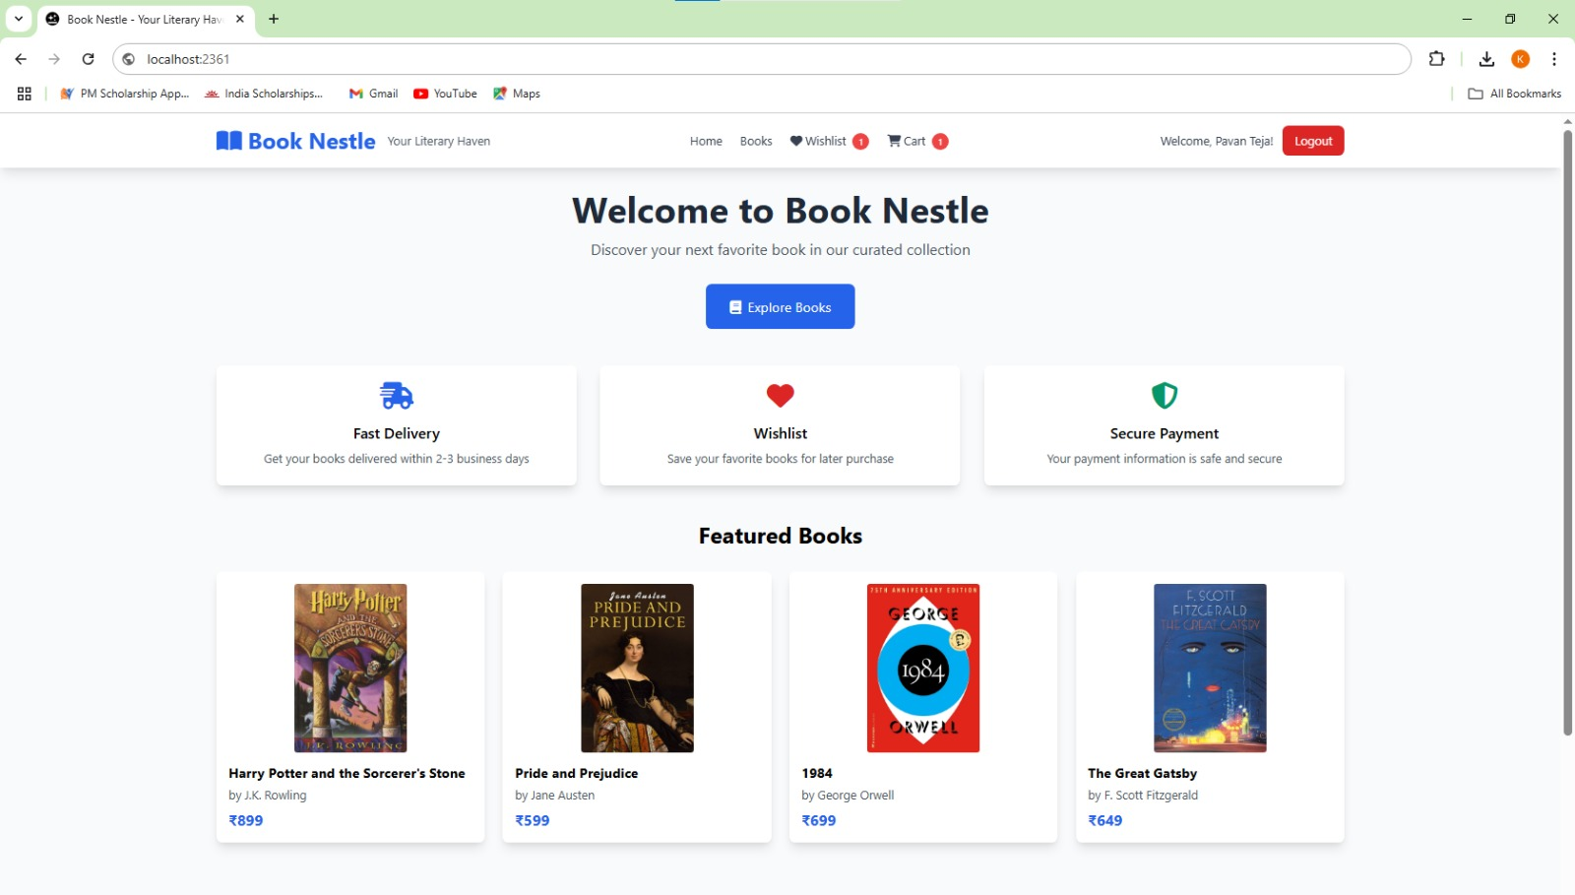

WISHLIST:



